Knowledge transfer document
Yuanhao (Jim) Liu
University Of Waterloo
Web App Interface and User Experience
(2022.11) Fixed white page backend communication disconnection bug after 5 approvals on request management page
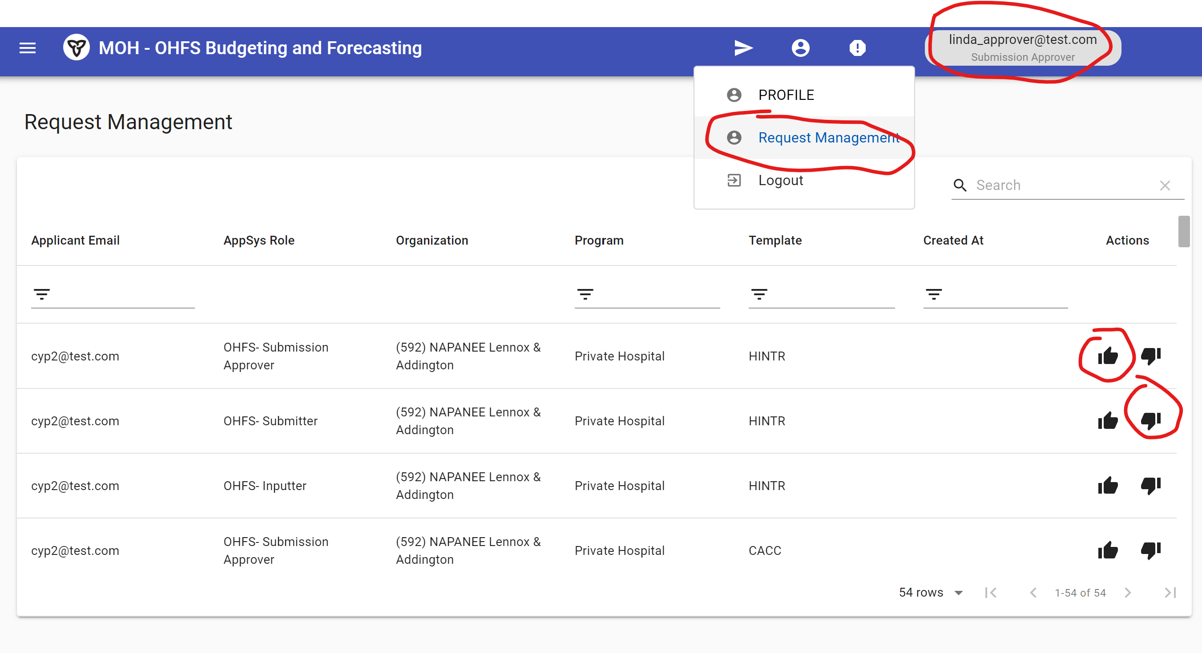
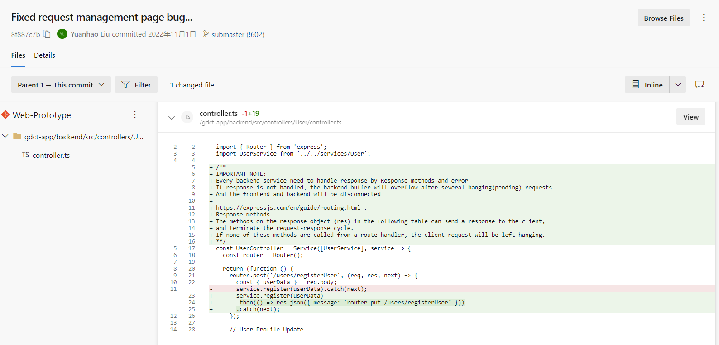

(2023.3) Enable the non-horizontal scroll material table (no need to horizontally scroll to view all columns) for 1920x1080, 1366x766, 2736x1824 resolution for Report Submission Status Page
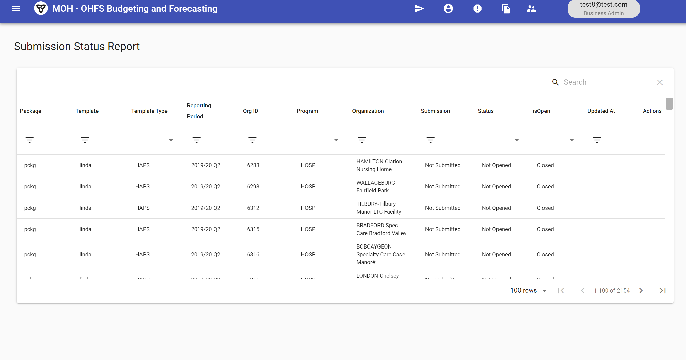

(2023.3) Discussed trade-offs for better user experience and easier coding difficulty on the template design phase action page, considering options such as peek workflow chart, PowerBI shape action flow, 2-way jumping button, and confirmation prompt
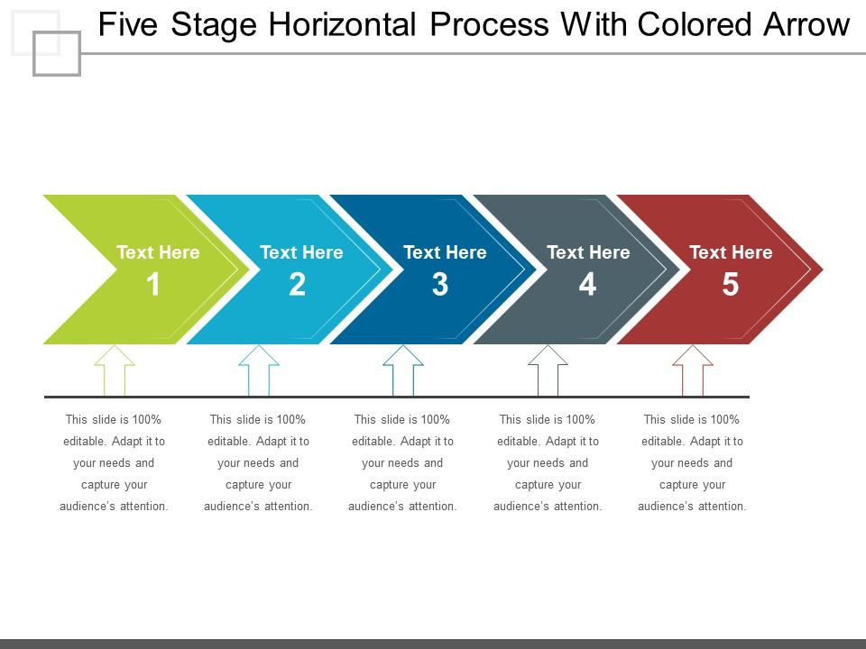
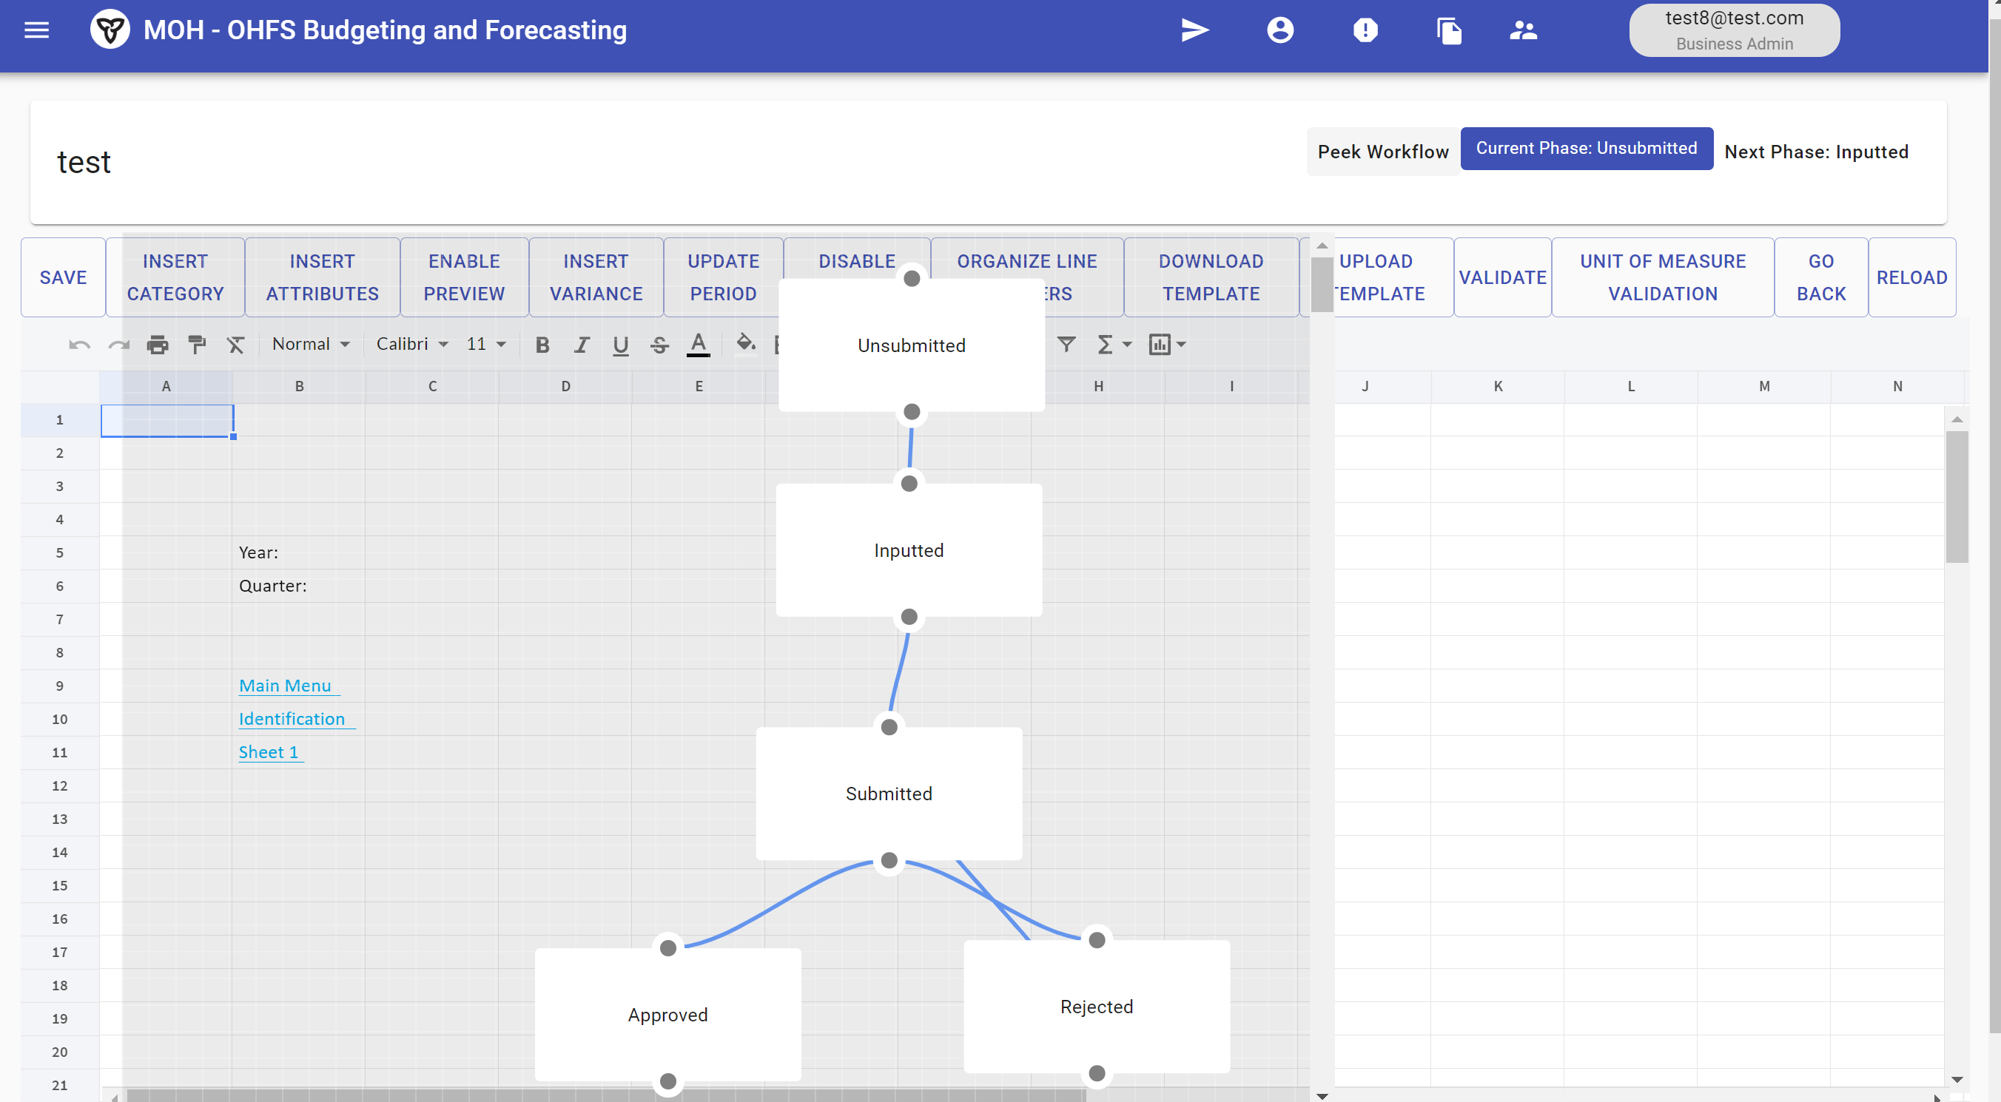

(2023.4) Added global filter functionality to all material tables
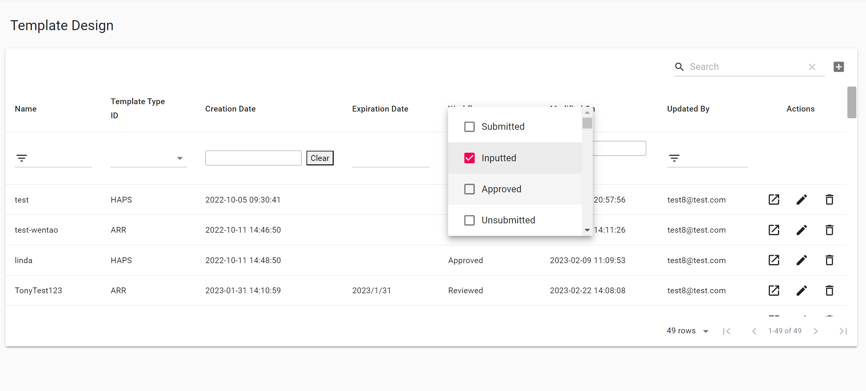

Page-specific Improvements and Fixes
(2022.12) Researched normal field non-editable issues related to adding and editing dropdown buttons on organization modification page
(2023.1) Added dropdown organization function on organization modification page and fixed non-editable issue caused by async useEffect
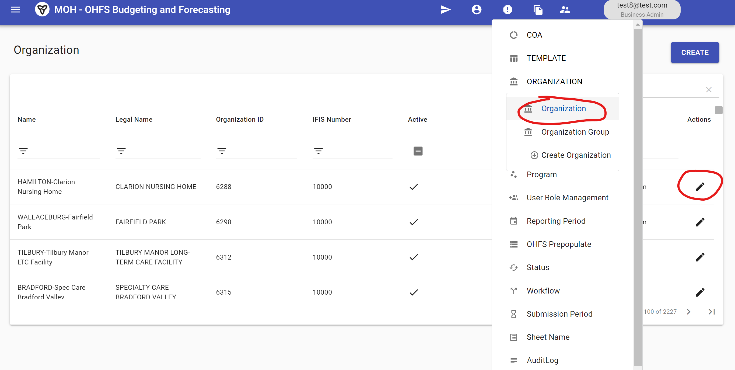
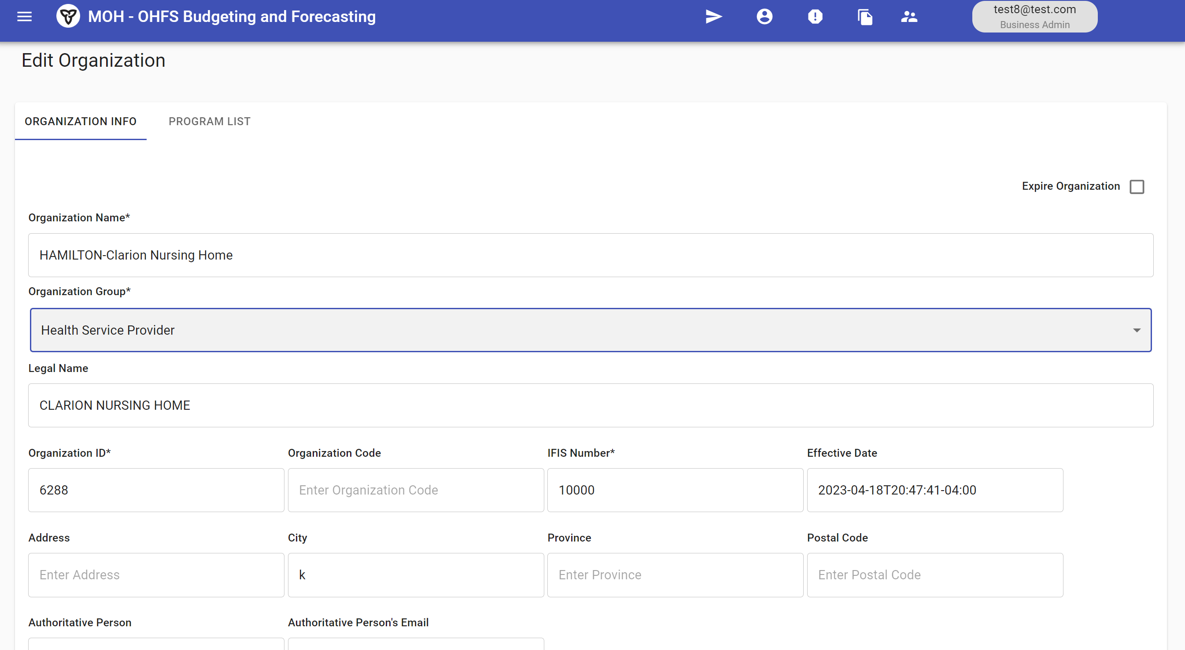
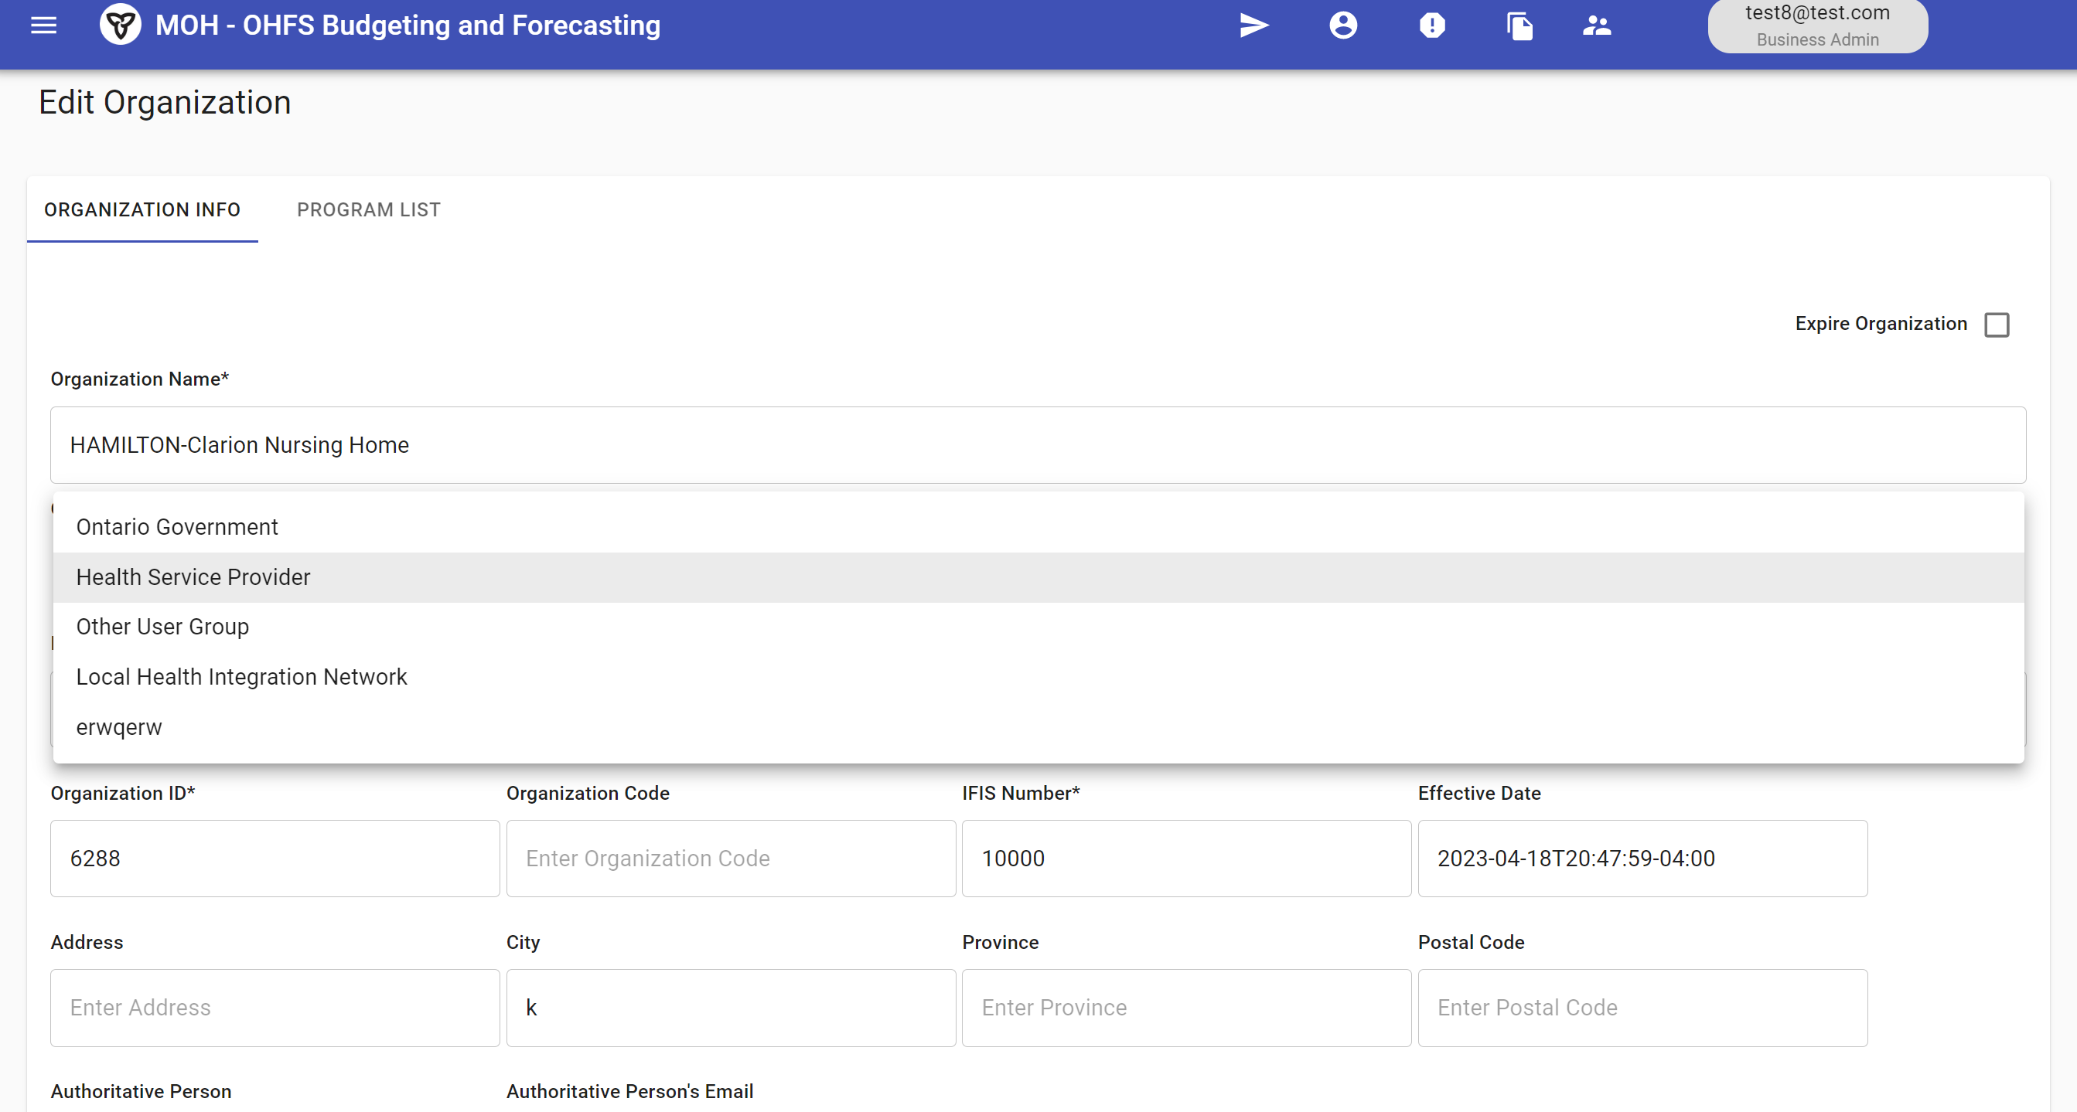
(2023.1) Added missing 'unit' column to the COA category page
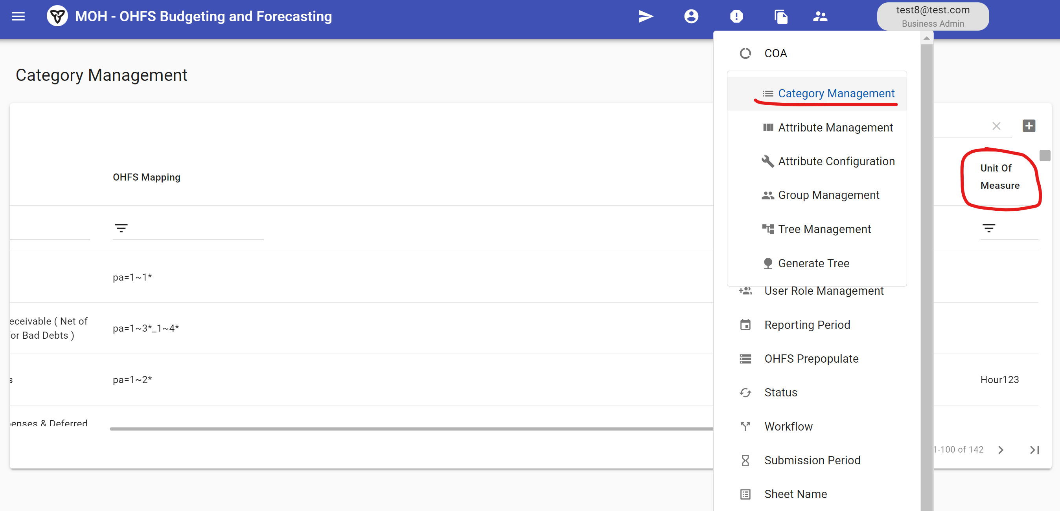
(2023.2) Added default name for the organization page

(2023.3) Changed title format for all pages and global header format, and added a new title to the user information modification page

Template Design Instances
(2023.2) Resolved newline parse error in cells of template design instances and solved incomplete commit revert issue
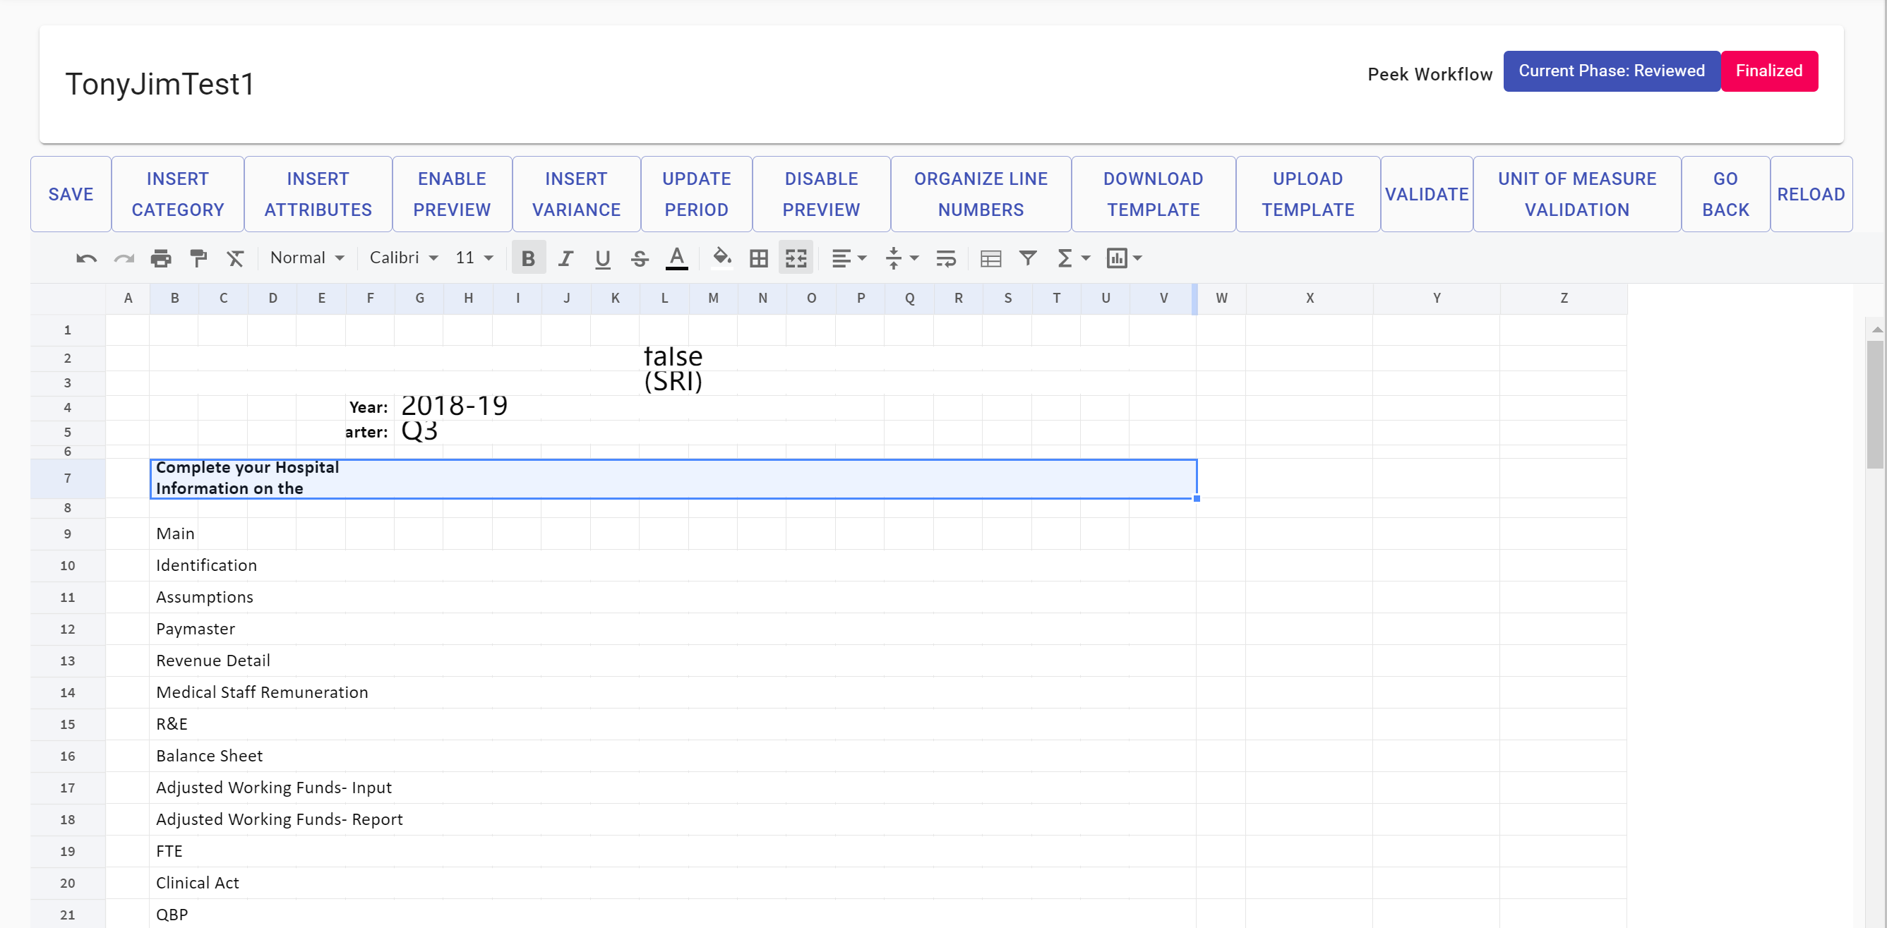
(2023.2) Enabled compatibility between template design import background color and index color
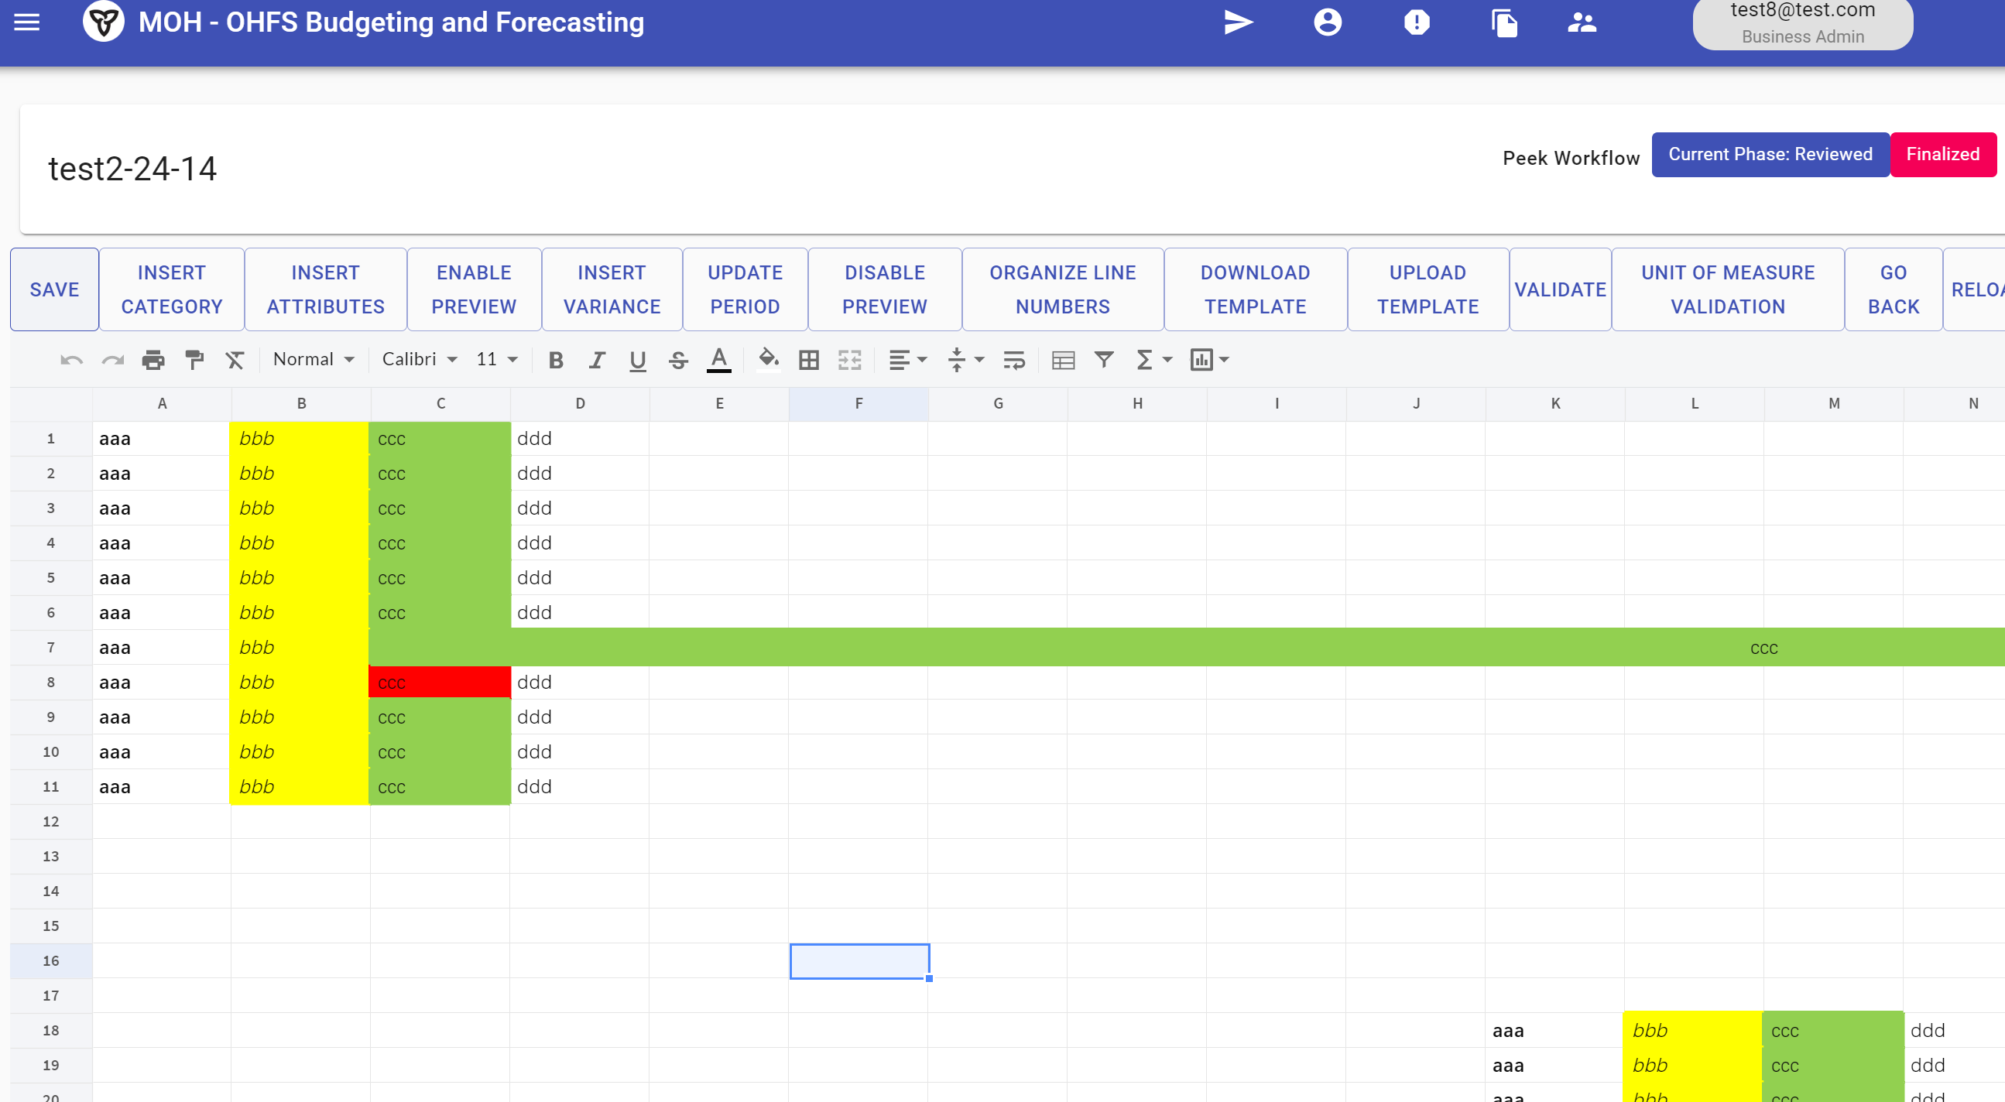
(2023.2) Added confirmation prompt for phase action changes on template design instance page

(2023.3) Set peek workflow chart near phase action to read-only mode

Date and Calendar Components
(2023.3) Added a calendar component for date picking fields
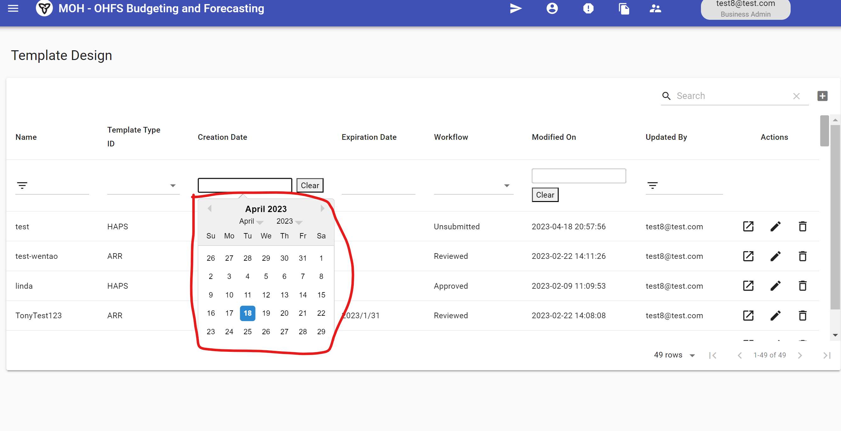

(2023.4) Adjusted parameters for the calendar box to prevent DatePicker widget from blocking buttons or causing them to drift
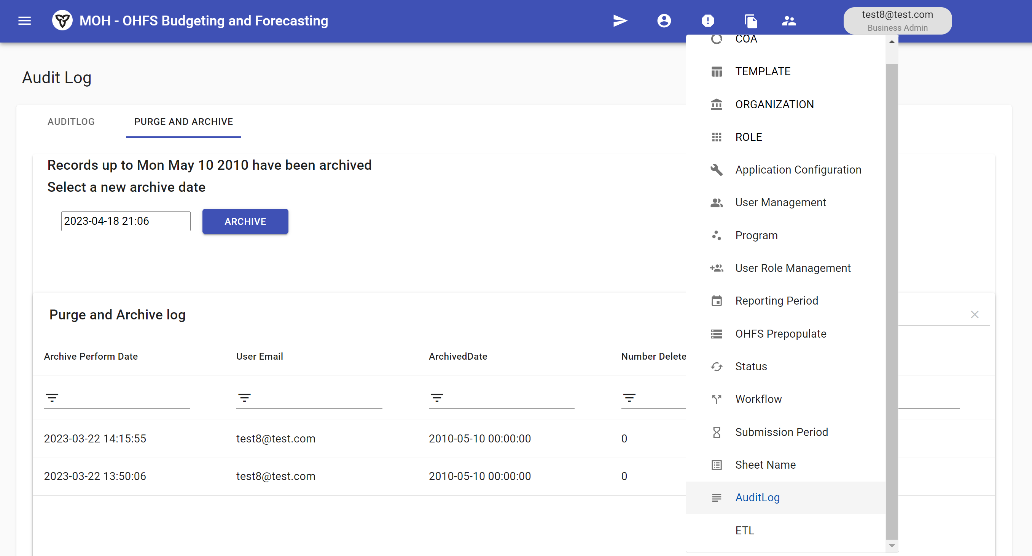
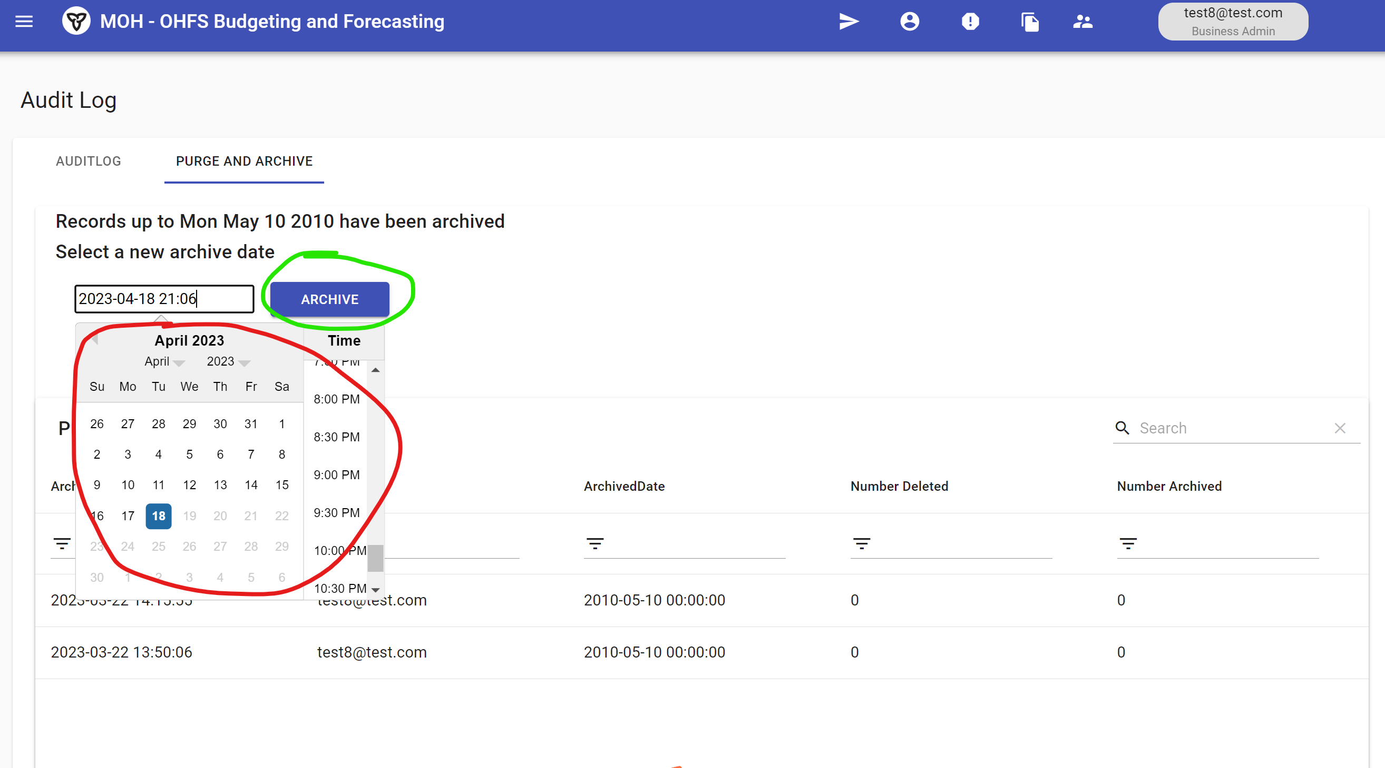

(2023.4) Provided three different styles for date-related material table fields and enabled reusability of the RangeDatePicker component for all other date-related material table fields
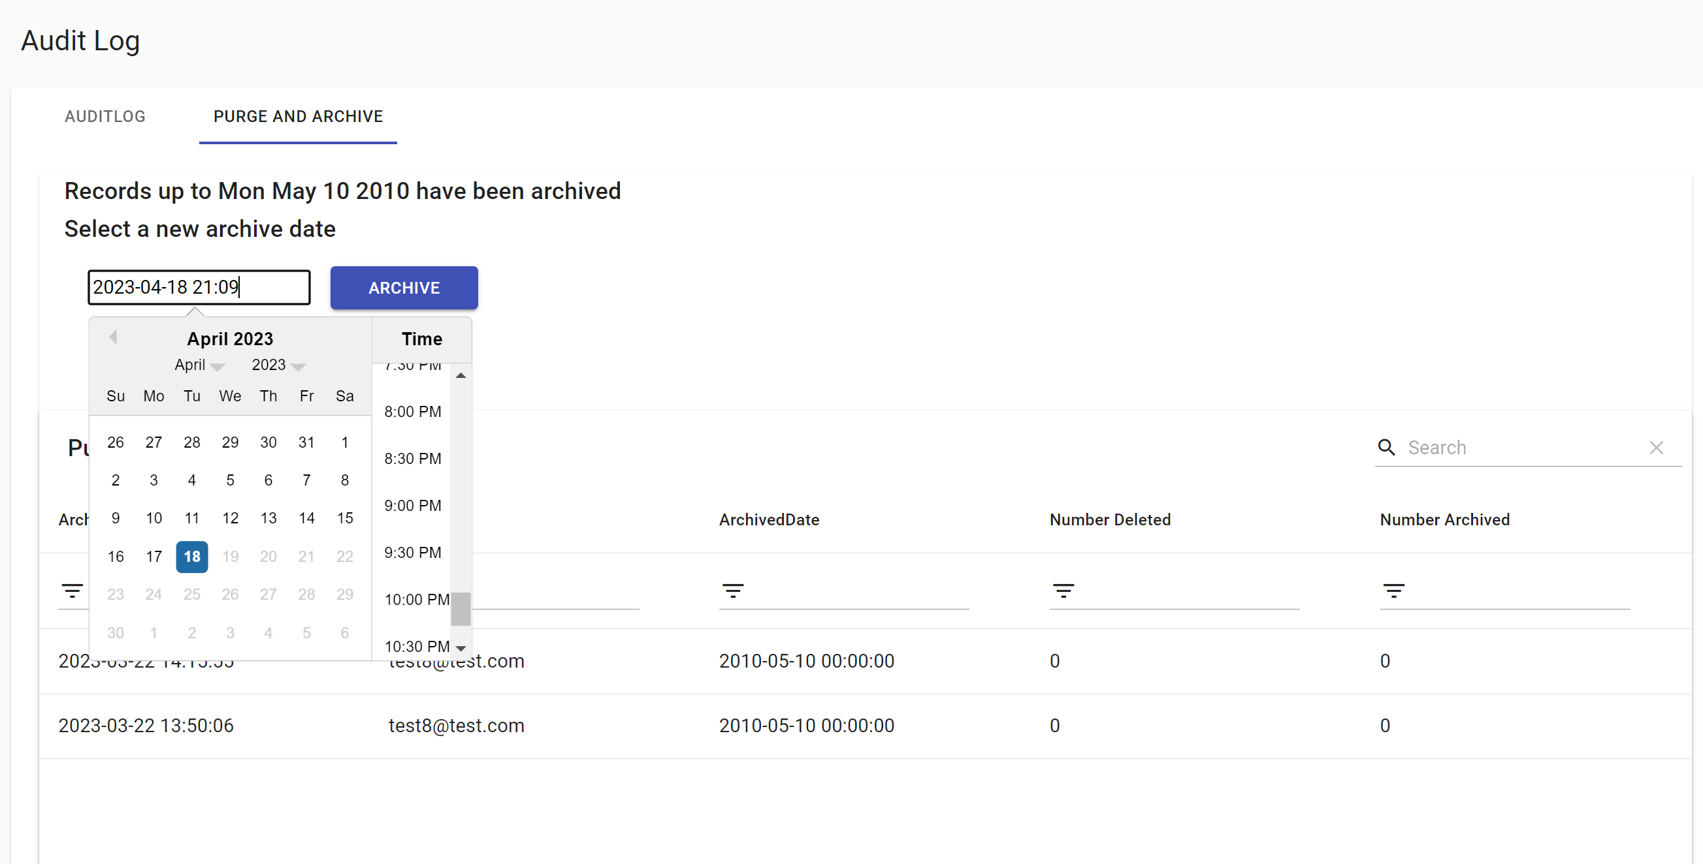
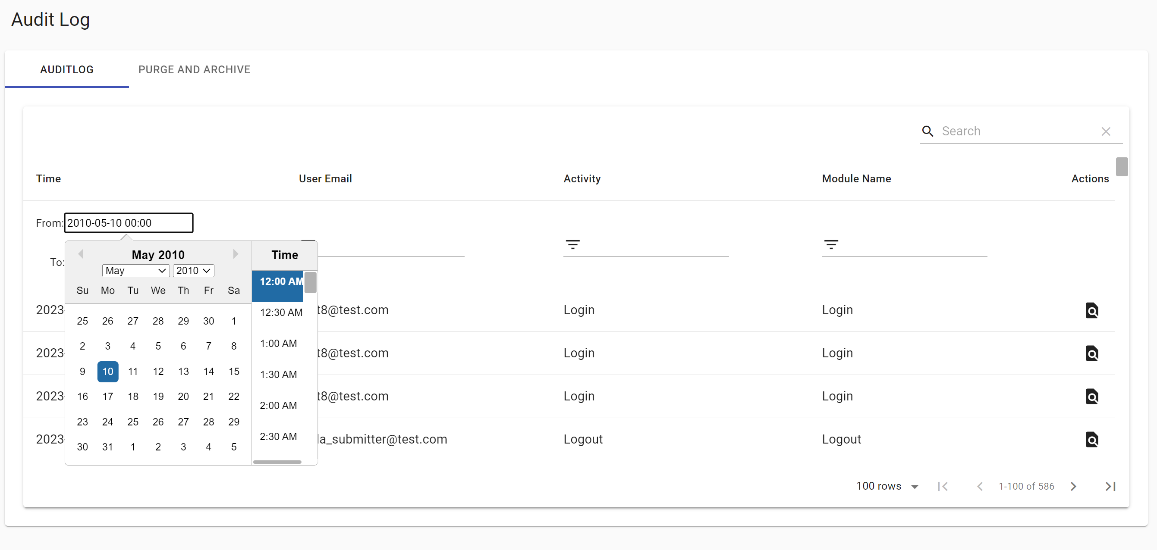
Debugging and Documentation
(2023.1) Drafted a short manual for the web app developer's UI
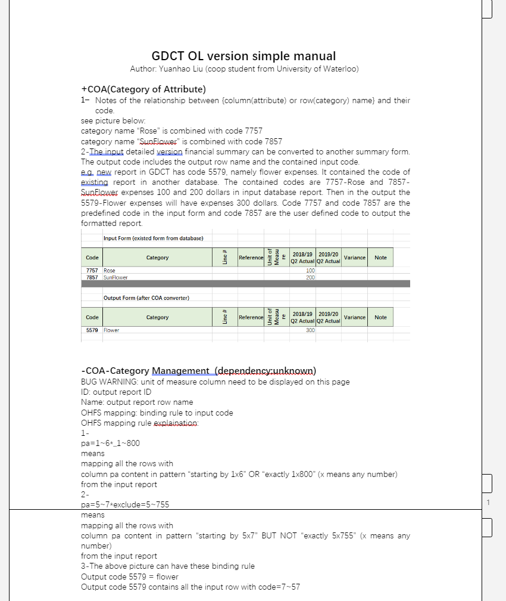

(2023.3) Created a new version of the AppError debugging document for future use. The AppError of 'WorkflowProcess not found' occurred in specific cases in both OL and local versions. Tested different assumptions at the database relation level and documented the steps to reproduce the issue, as well as the most likely causes of the bug (either incorrect backend database direct operations or frontend bugs).
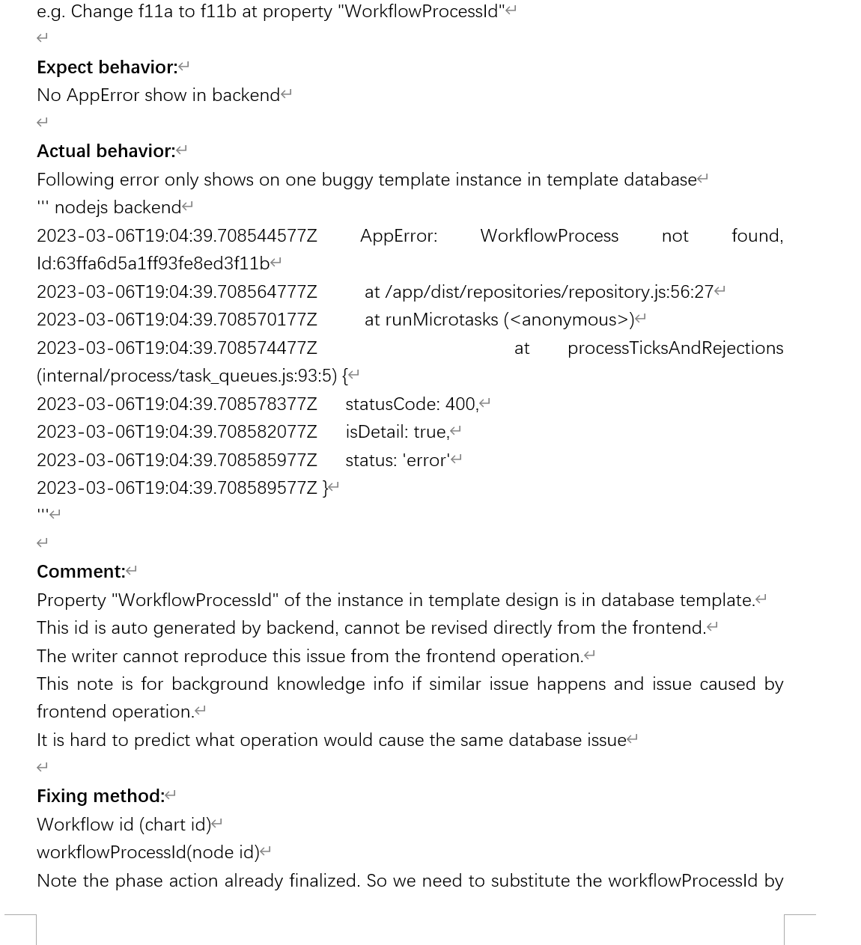

Debugging Notes:

Frontend shows white page and console displays fetchByEmail error:
Global search service fetchByEmail in the backend service and verify commit record to ensure if your branch affected the fetchByEmail-related backend service or misused it.
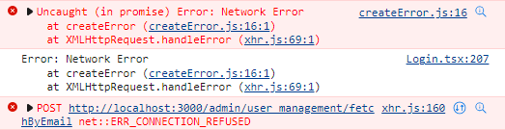

Wrong React Hook issue and possible memory leak error:
Check if the previous version (local and OL) has this error.
Ensure all useEffect and useMemo hooks work correctly.
Verify if useEffect is correctly coded with async functions.

Environment installation failed error:
Review online compatibility dependencies for node-sass and node.js versions.
Examine Python-related installation requirements.
Check system environment settings. (search python system environment setting)

Local Backend console displays database connection failed issue:
Verify if local frontend and backend files use the local version. Note OL version and local version uses different frontend and backend env file.
DCT database is OL database, local branch should use DCT_YourName database to avoid the pollution operation

Commit method:
In VS Code's left navigator source control, select all files to commit (excluding env files), press '+' next to the file or 'Changes', add a message above the commit button, and commit. All commits require a message.

Commit not appearing in Azure DevOps:
Commits are temporarily saved locally if you do not manually run push command to upload your commit in git bash.
After committing contents, push from the local branch to the remote branch using "git push origin branchOfYourName" in git bash command line.

Normal code review procedure:
Develop in the local branchOfYourName.
Complete testing in the local branchOfYourName.
Commit to OL branchOfYourName.
Launch pipeline of OL branchOfYourName after confirming team member pipeline availability.
Finish testing in OL branchOfYourName.
Request project manager to test OL branchOfYourName.
If the project manager approves testing, manually create a pull request (see image below) to transfer code from OL branchOfYourName to OL submaster.
Launch pipeline of OL submaster after confirming team member pipeline availability.
Finish testing in OL submaster.
Request project manager to test OL submaster.

Normal 2-way merge procedure for your branch and submaster:
Create a pull request from OL submaster to OL branchOfYourName (introducing new commits from other team members).
Resolve conflicts if they appear.
Create a pull request from OL branchOfYourName to OL submaster (conflict resolution is not needed as new commits from other team members have already been introduced).

Azure DevOps issue debugging:
Azure DevOps issues may appear as a grey page with an 'Application Error, contact website admin' message. Don't freak out or panic when debugging Azure DevOps issues. Most are caused by backend service bugs. Ask the project manager to access their restricted management page, where they will find the backend log. Analyze the OL backend log similarly to the local backend log. If confused by partial OL backend logs, check timestamps to identify today's logs. Note that there may be a 5–8-hour time difference between the OL backend log and local time in Toronto. Test the accurate time difference by trigger specific service and record time then search that service in OL backend logs to calculate the time difference.

Pull request and commit differences:
For OL to OL, use the pull request button UI in Azure.
For local to OL, use the git bash command line 'git push origin branchOfYourName'.
For OL to local, use the git bash command line 'git pull origin branchOfYourName'.
It is highly recommended to operate ‘local to OL’ and ‘OL to local’ for only the same named branch to avoid git issues that are hard to debug and revert.

OL login page white page issue:
Wait 40-60 minutes after launching the pipeline.
If the issue persists, inspect the frontend console by right-clicking and selecting 'Inspect'.
In rare cases, you may need to relaunch the pipeline 1 or 2 times for the OL version to work. This occurs 1-2 times per month.

Pipeline running tip:
On certain days, the pipeline runs automatically for submaster between 5-7 PM. To avoid issues, do not run the OL branchOfYourName pipeline on one day at 4 PM and expect to present the OL branchOfYourName on next day at 9 AM without checking the pipeline settings at 8 AM on next day.

Additional Tips and Best Practices:

Udemy training video tutorial learning methods:
Focus on how-to-revise level knowledge and roughly familiar with topic contents.
Do not need to recite every detail or recite the procedure of how-to-develop-from-zero.
Most important thing is when you encounter the similar topic or grammar in the project, you have at least half memory of what it is and where the related tutorial is in the Udemy tutorial so you can review.
If you copy the procedure of tutorial but the result is not as same as video, check whether node.js version or node-sass whether too new. Then check high star comments under that episode of the video to see whether there is some update of environment issue.

Communication:
When facing coding issues, spend 20-30 minutes researching solutions on Google. If the problem persists, consult with team members or the project manager, explaining the context of the issue and the methods you've tried.
For concerns regarding dress code, holiday schedules, sick leave, or recent performance, directly approach your supervisor for clarification.
If you feel your progress is too slow, discuss your attempted methods and your 5-day plan with the project manager. Together, decide whether to continue with the current task, switch to another task, or involve additional team members.
If you find that a task requirement is difficult to code and have an alternative method, discuss the trade-offs during daily meetings. This can lead to potential requirement changes or the development of a draft function, especially if you can finish the alternative method and display the UI within 2-3 days.

Documentation:
Include comments in your code, particularly for challenging bugs, nested functions, and uncommon syntax.
Avoid using overly short names without providing a comment explaining the full name or abbreviation.

Testing:
Consistently test your local branchOfYourName and OL branchOfYourName before merging your commits into the submaster branch. This will prevent disruptions or pollution to other team members' work in submaster branch.

By following these tips and best practices, you'll effectively contribute to your team's success and ensure a smooth development process for your project.

Launch pipeline position:
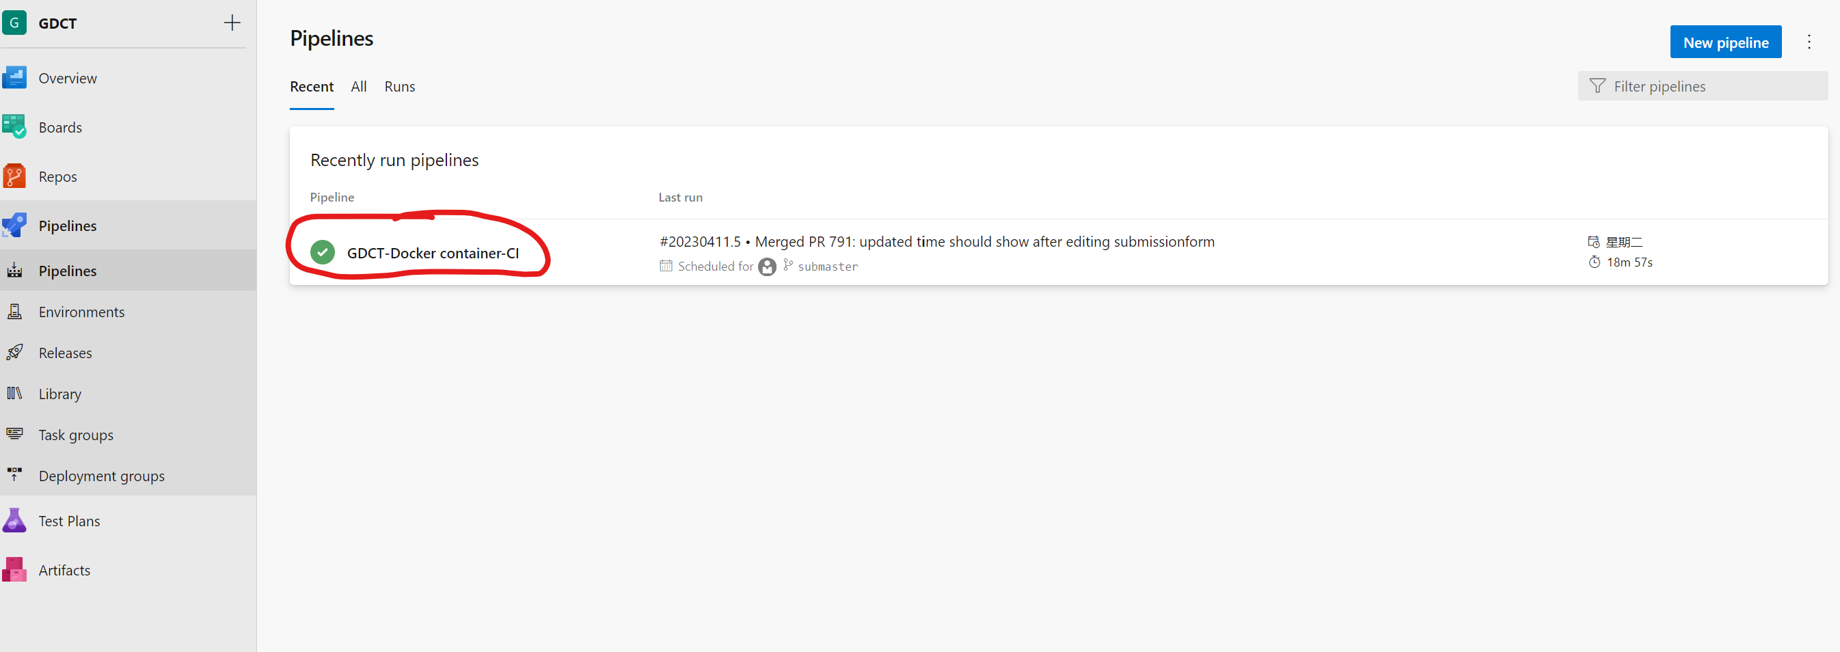
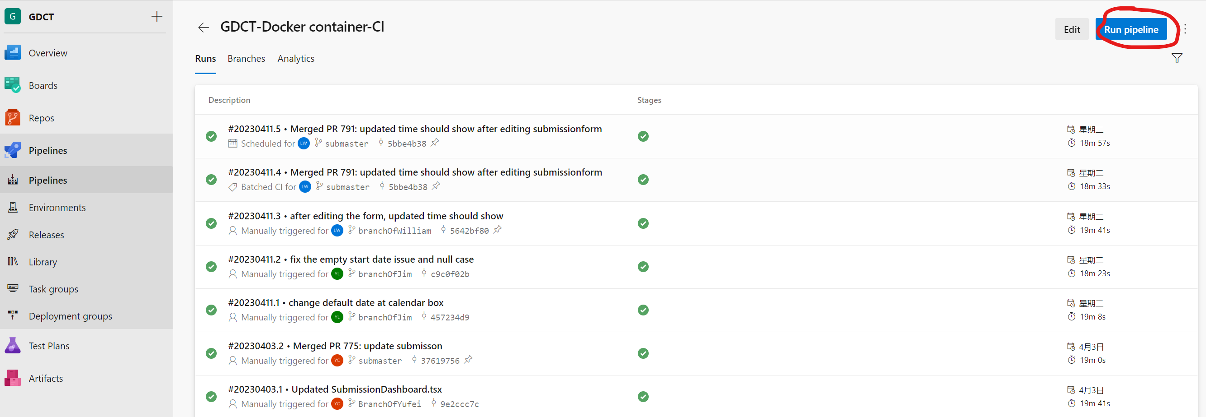
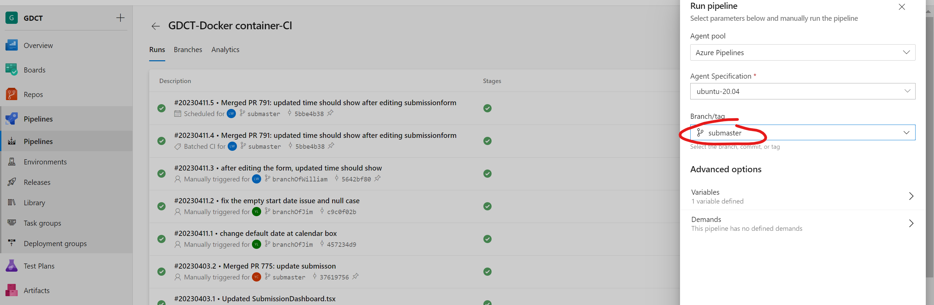
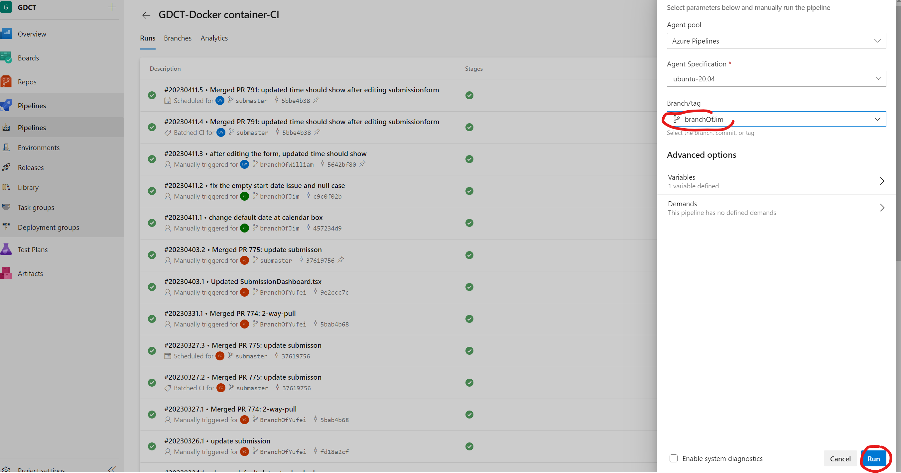
Pull request position:
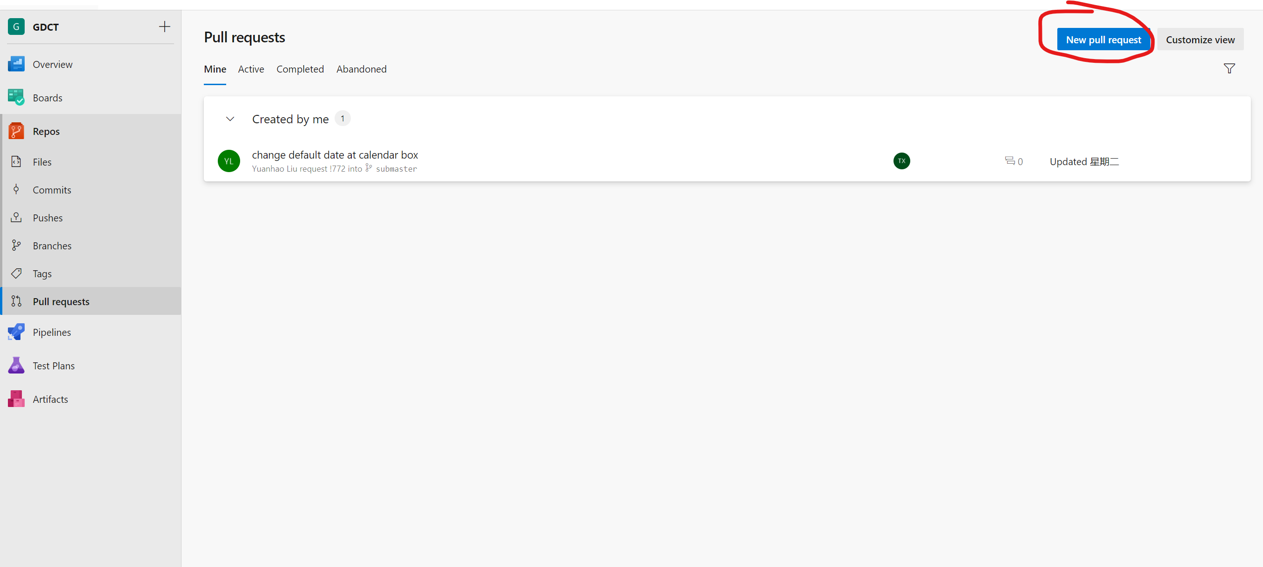
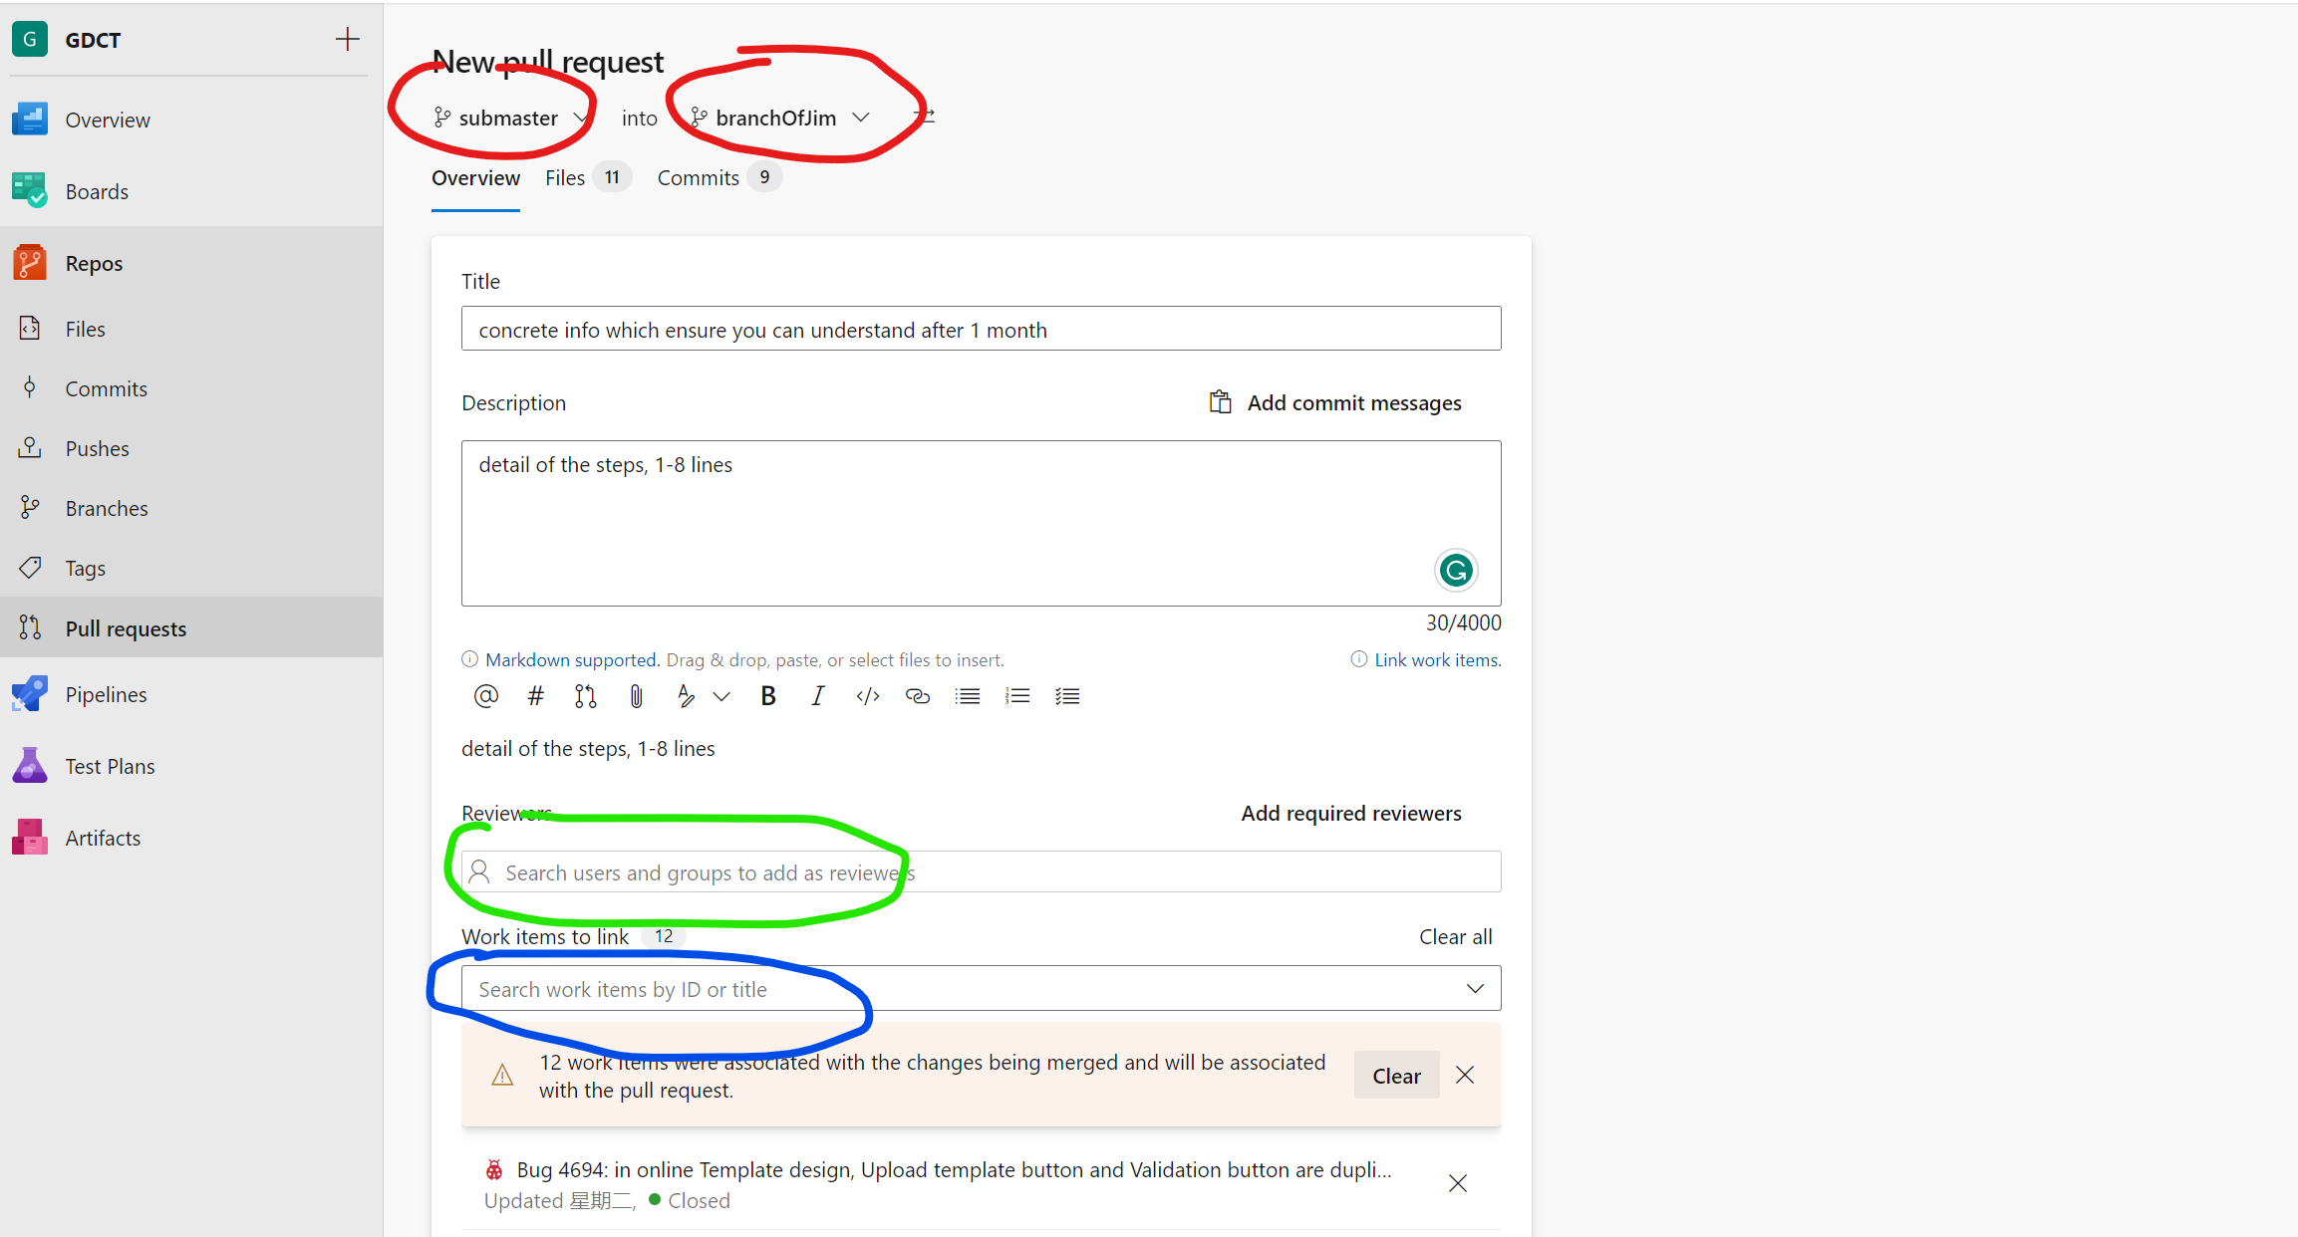
Red part – add new commits from submaster to branchOfYourName without deleting new commit in branchOfYourName
Green part – add the project manager name
Blue part– enter 4-digit work item number of the task, check your email

